**Exhaustive Analysis of Indian Agriculture using Power BI**

**(Week-1)**

**What is BI?**  
Business Intelligence (BI) refers to tools and processes for analyzing data and providing actionable insights.

**What is Power BI?**  
Power BI is a Microsoft tool designed for analyzing and visualizing raw data to provide meaningful insights.

**ETL Process in Power BI**

1. **Extract**: Import data from sources like Excel, CSV, or text files.
2. **Transform**: Clean and process the data.
3. **Load**: Load the processed data for analysis.

**Steps to Use Power BI**

1. **Download & Install**: Get the latest version from the Microsoft website.

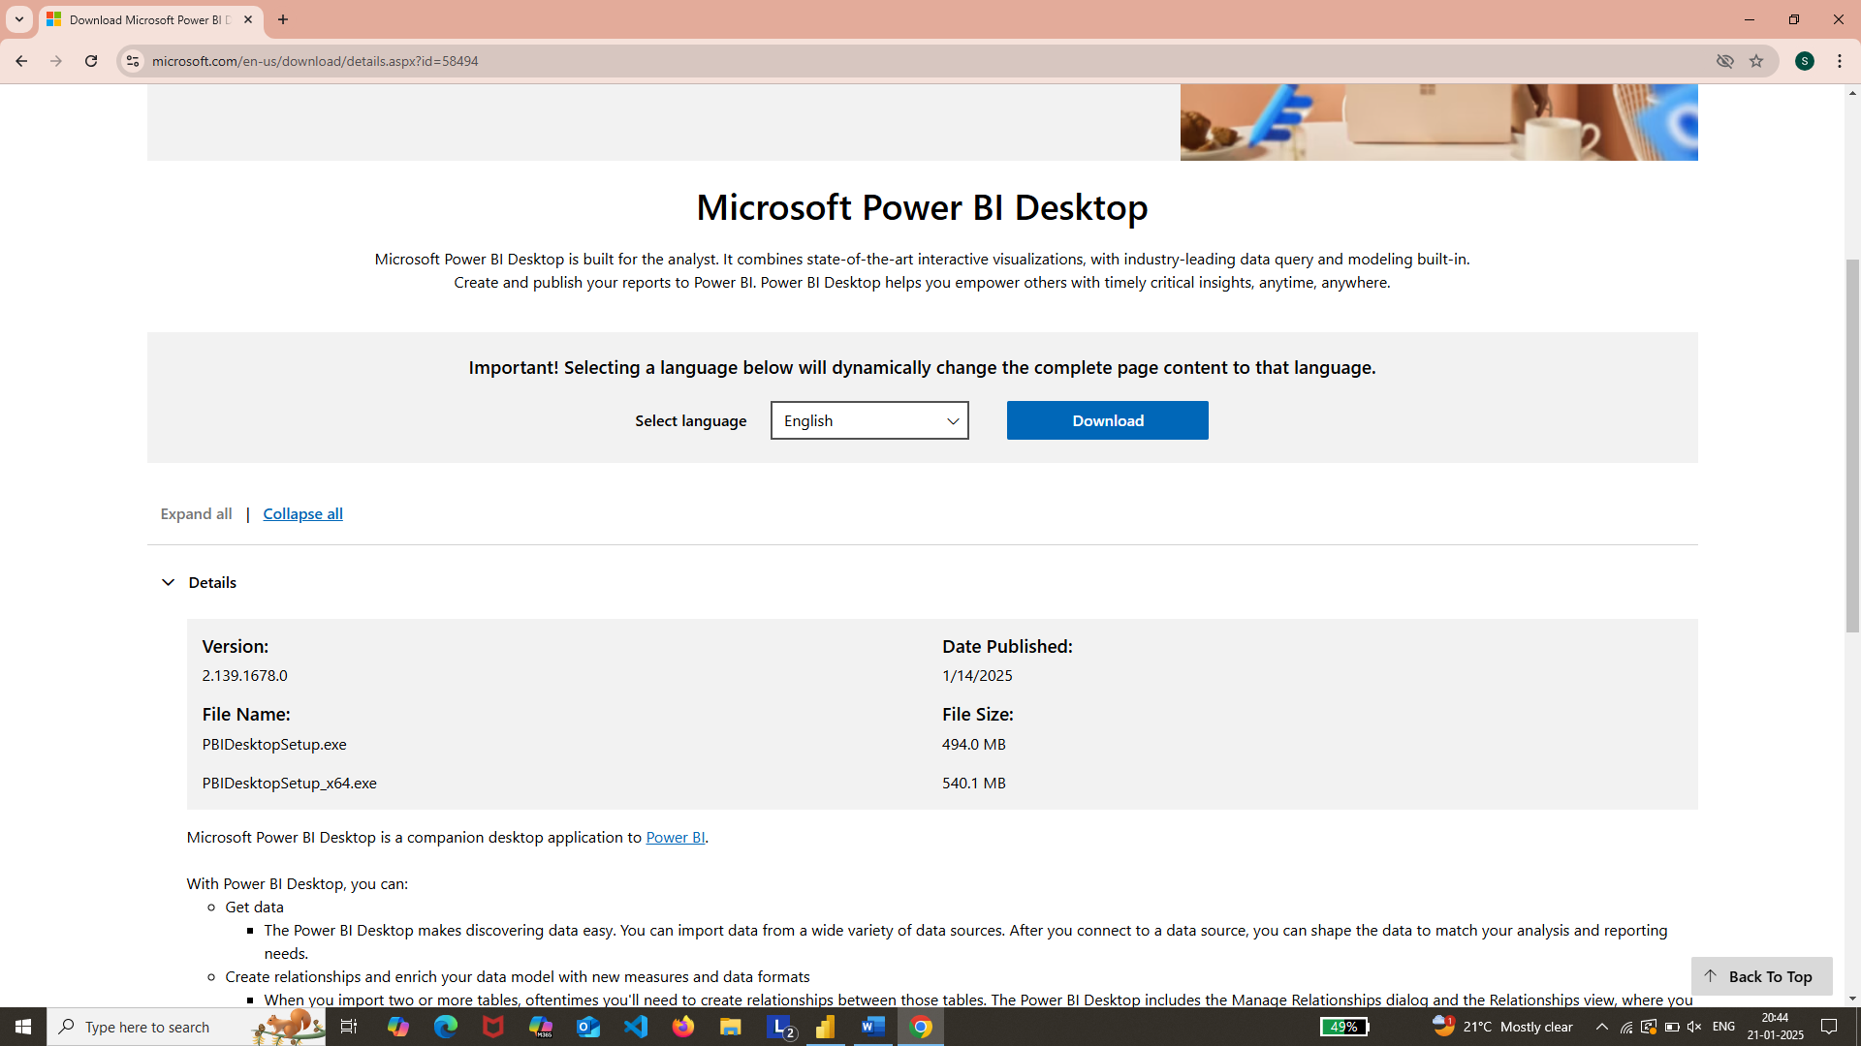

1. **Open Power BI**: After installation, start with a blank report.

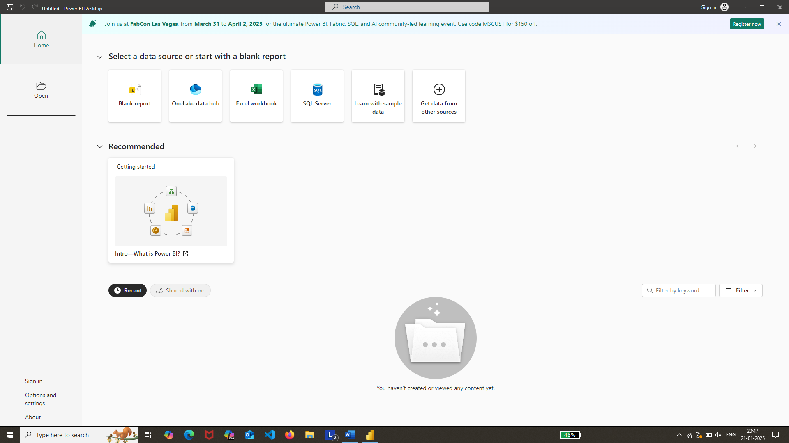

1. **Import Data**:
   1. Click **Get Data** and choose the data format (e.g., Text/CSV).

* 1. Select the dataset file.

* 1. Choose:
     1. **Load**: If the dataset is already clean.
     2. **Transform Data**: If cleaning is required.

**Data Transformation**

1. **Power Query Editor**:
   * Opened when you select **Transform Data**.
   * Delete unnecessary columns by right-clicking the column name and selecting **Remove**.
   * Remove empty columns the same way.

1. **Check Data Quality**:

* Go to the **View** menu and select **Column Quality**.
* Ensure all columns are 100% valid.

3. **Finalize Data**:

* + Click **Close & Apply** to load the cleaned data.

